ET-based Irrigation System with Automated Bird Deterrent System
Alternative Title:
AI and IoT based Migration birds monitoring and survey system in bird sanctuaries.
Aim:
Aim of the project is to build a small and portable bird classification device to monitor and survey migration birds in sanctuaries with the help of AI and IoT.
Synopsis:
The monitoring of birds has a widespread potential in numerous applications in ecology, climatology, and avian related zoonosis /infections such as avian influenza. Migratory birds are known to be carriers of the birds’ flu, caused by type A of the influenza virus H5N1 and they can infect domesticated birds. This virus can cause severe disease in humans, but at present it cannot transmit easily from person to person, although fatal human cases were reported. By monitoring wild bird migration a better understanding of the flyways used by the various avian species can be gained.
There are lot of conventional methods are exist to monitor migration birds such as manual monitoring, RADAR systems and webcams. Manual Motoring requires lot of man power and time consuming process. RADAR system faces a huge problem with ground echo signals which make difficult to identify source of receiving signals whether it is from birds or ground. Installation of web camera to capture video of bird needs a computer, relative power source and networking system.
In our proposed system, we are using a portable, small ARM based computer (Raspberry Pi) to control the camera and network. It requires minimal amount power when compared other computers. With this raspberry pi, we can add raspberry pi camera as well as USB camera to capture video. This board has the ability to run machine learning models to recognize the bird. This device can be used in bird sanctuaries to identify the different bird species. It will help to gather the large amount data in limited time period with minimal man power. It can be placed any bird habitats like trees, hills tops and any other remote places.
Existing system:
Existing system uses raspberry pi to control irrigation system and bird deterrence. Irrigation system works based on evapotranspiration which is calculated based on solar radiation, temperature, humidity, and wind speed. Image processing was used for the bird detection; Opencv was used for object detection, using a trained Haar cascade model in order to detect birds. While a rotating red light was used for the bird deterrence.
Proposed system:
In proposed system, we are using trained CNN model to detect the birds and recognize them. Raspberry pi camera is used to capture the video and it fed the image frame to machine learning model. If any values matches with exiting model values system labels the recognized bird with name and store the picture in local storage. Using portable Wifi module we can establish the network connection with cloud database. Collected data are uploading to cloud with the particular interval of time.
Block Diagram:
Raspberry Pi Camera
Raspberry Pi 4
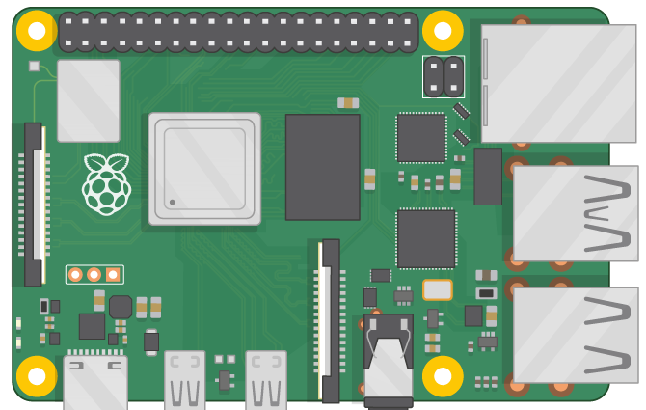

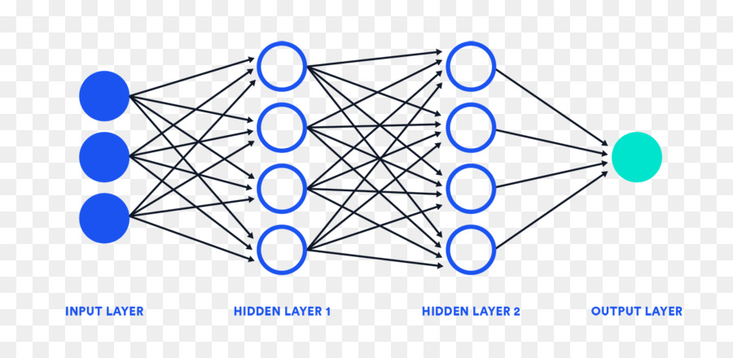
Neural network
Cloud Database
Portable Router
Birds

Block Diagram Description:
Here, Raspberry pi act as main controller which is responsible for connecting all the components together. Raspberry Pi camera is used to capture the video and fed to micro controller as frames. Every frame is deployed into CNN model to recognize the birds; if bird detected then it will store in local storage. Wifi router is used to establish connection between local storage and cloud storage.
Hardware Requirements:
- Raspberry pi 4
- Raspberry pi camera
- Power supply module
Software Requirements:
- Language : Python
- Compiler : GCC Complier
- OS : Linux

